**Storyboard**

For the user interface of the game the proponents are going to use an all grey palette to enhance the mood of the game. The proponents chose this palette because dark colors convey feeling of unease. The tool selected for blending colors came from [www.colorblender.com](http://www.colorblender.com).

When a user opens this game the splash screen will show up. The splash screen contains the logo of the game while it is loading.

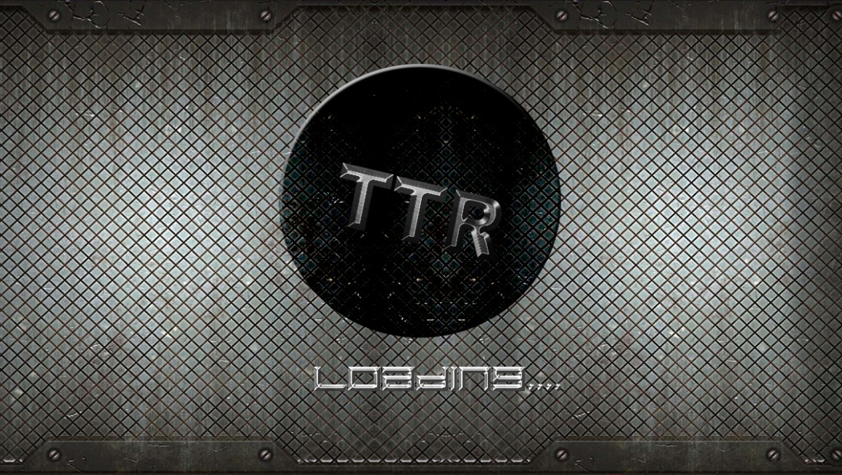

*Figure 3.2 Tap the Robber: Splash Screen*

After the game has finished loading the main menu will show up with the following options new game, instructions, shop, options.

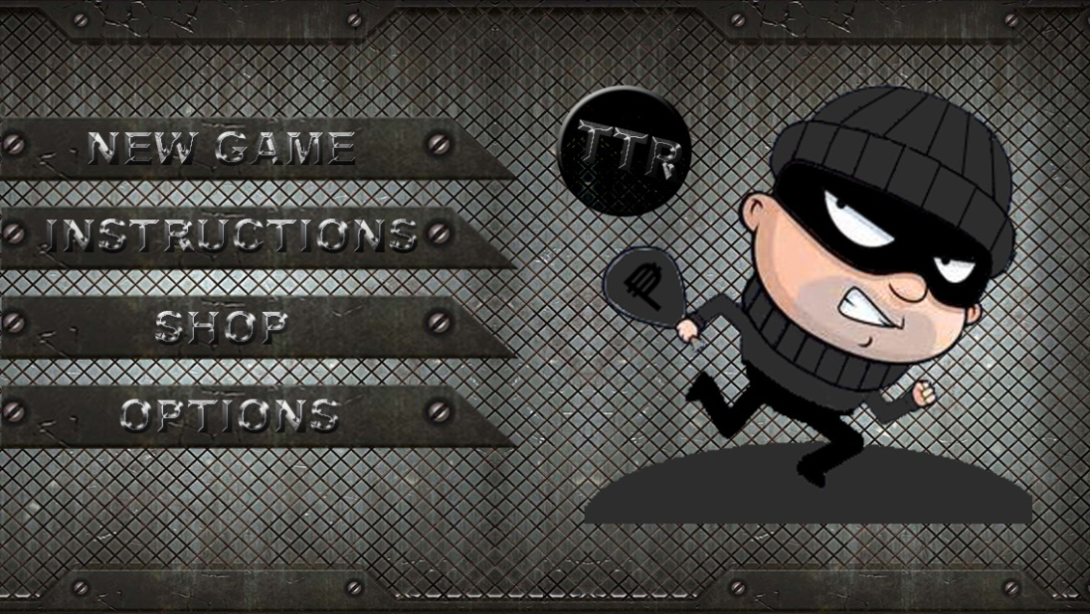

*Figure 3.2.1 Tap the Robber: Main Menu*

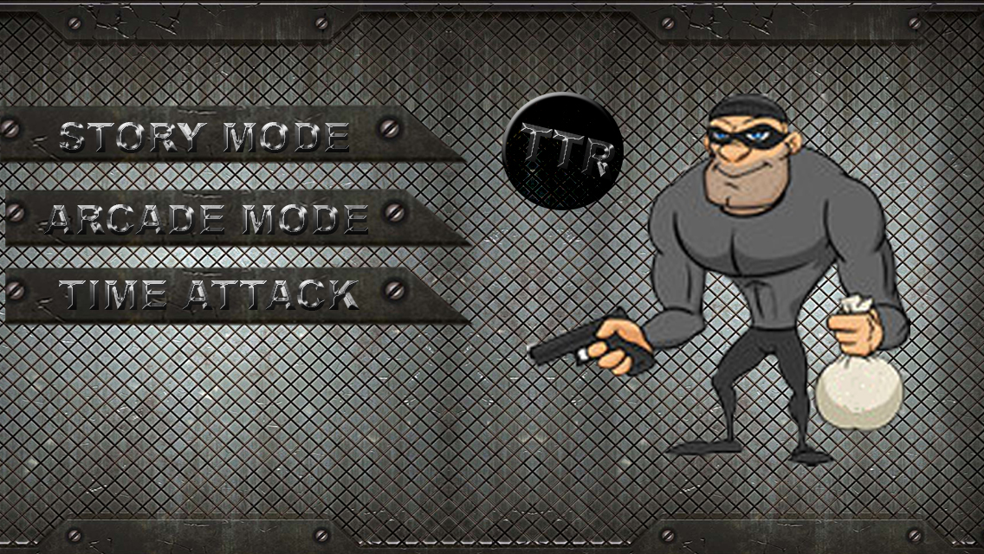

*Figure 3.2.2 Tap the Robber: Game Modes*

When the user taps or presses the instructions button the user will be redirected to the instructions screen wherein the instructions on how to play the game will be shown through pictures.

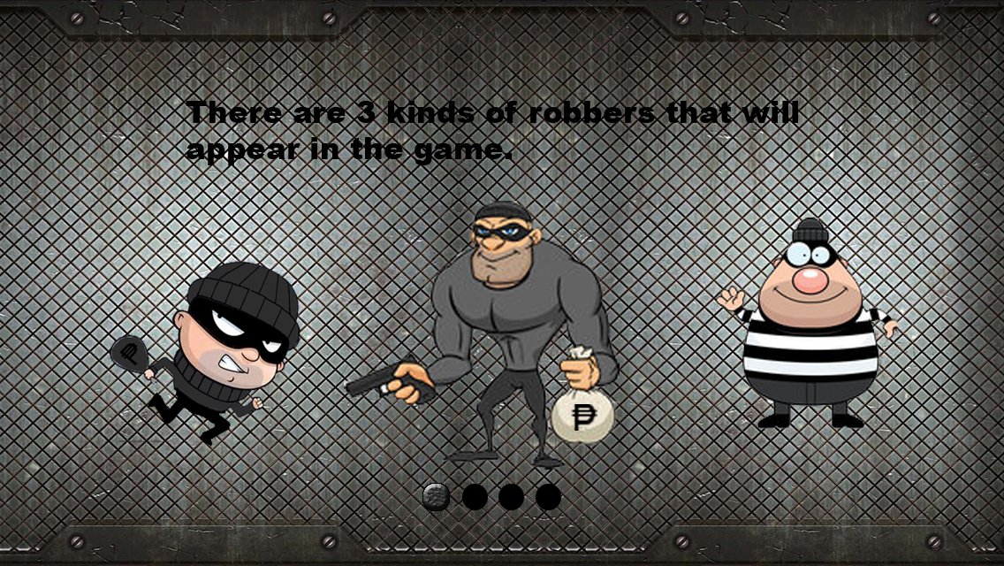

*Figure 3.3 Tap the Robber: Instructions Page 1 of 5*

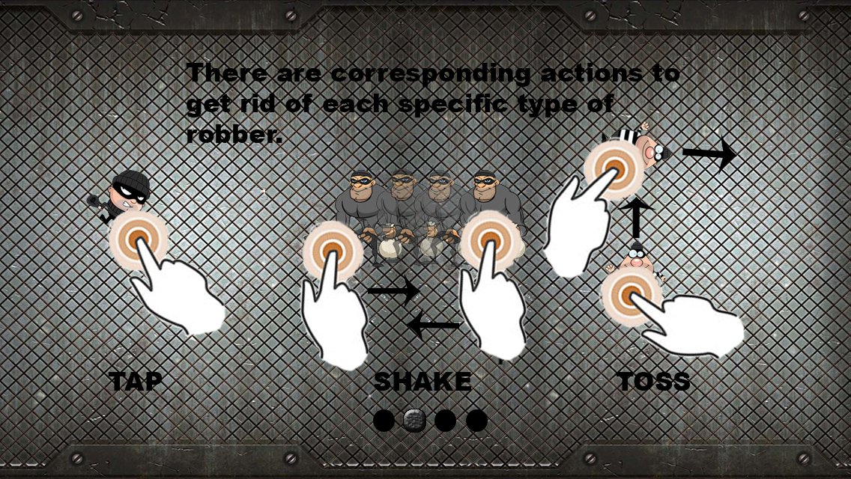

*Figure 3.3.1 Tap the Robber: Instructions Page 2 of 5*

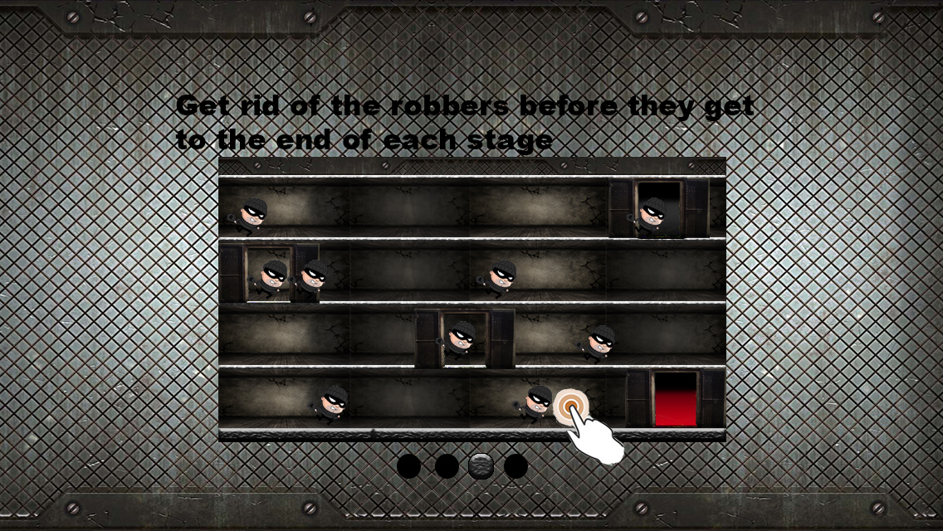

*Figure 3.3.2 Tap the Robber: Instructions Page 3 of 5*

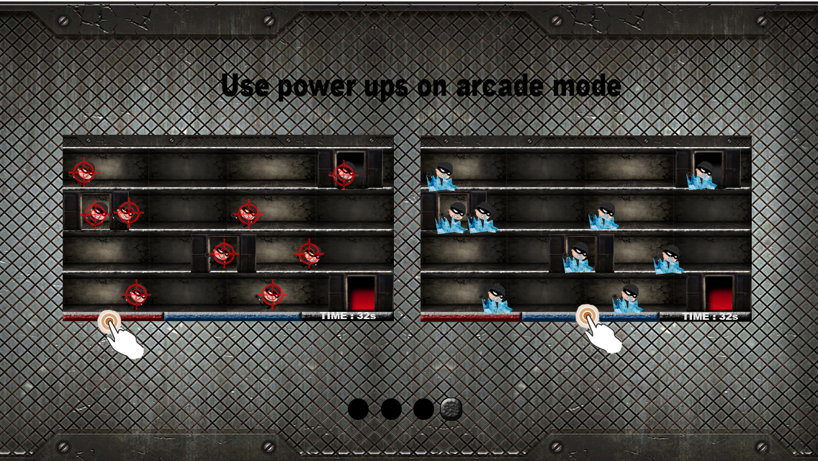

*Figure 3.3.3 Tap the Robber: Instructions Page 4 of 5*

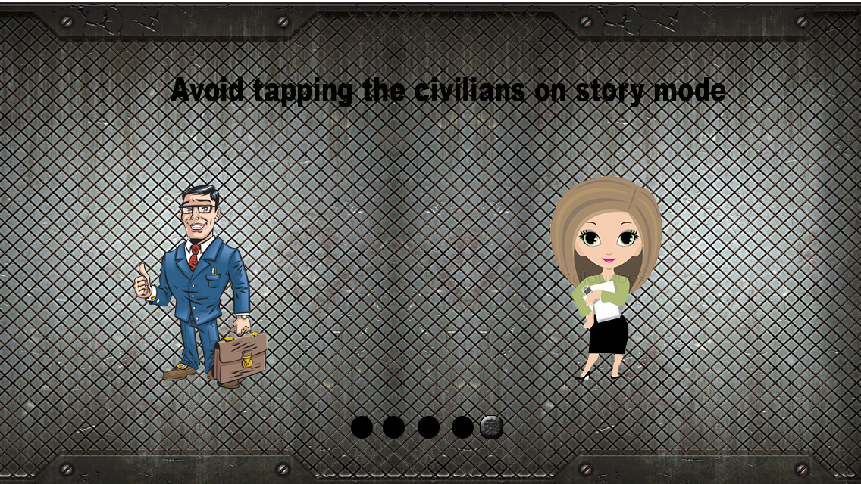

*Figure 3.3.4 Tap the Robber: Instructions Page 5 of 5*

If the player clicks the time attack option on the main menu the game in time attack mode will automatically start in 3 seconds. The status bar of this game mode is located above. The following details indicated in the status bar are as follows.

* Robbers Left per Level
* Current Level/Stage
* Time of playing

The Robbers will appear randomly on different doors for level 1 and they will continue to run to the edge until they disappear.

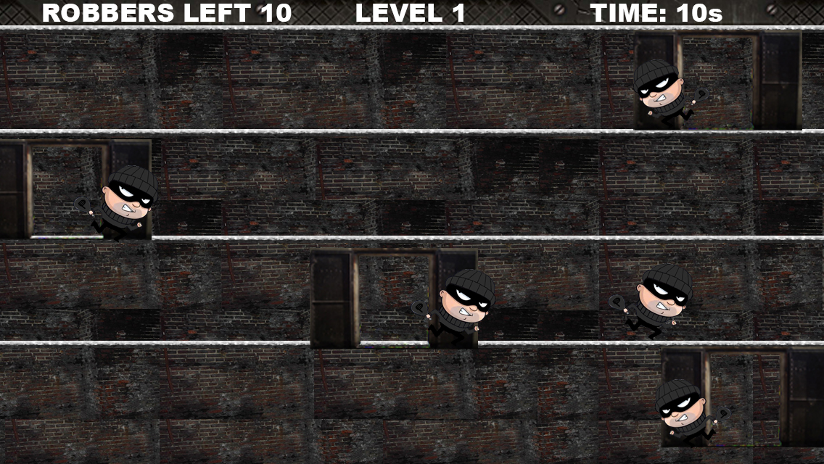

*Figure 3.4 Tap the Robber: Time Attack Level 1*

After the player finishes level 1 of the time attack mode the player will proceed to Level 2 in which the stage looks different and the number of robbers required to finish the level is increased. The robbers on level 2 will appear randomly thru stairs and doors

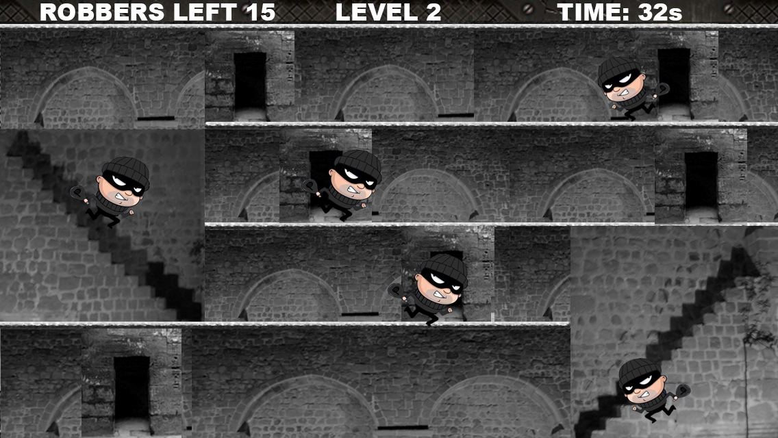

*Figure 3.4.1 Tap the Robber: Time Attack Level 2*

After finishing level 2 of the time attack mode the player will proceed to Level 3 in which the stage will look different again and the number of the robbers will be the same but there will be an additional robber in play.

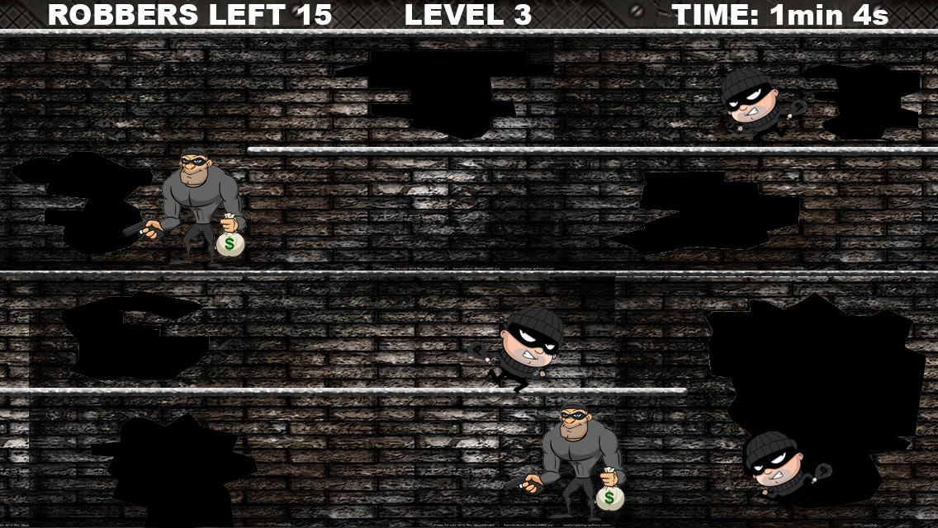

*Figure 3.4.2 Tap the Robber: Time Attack Level 3*

This goes on until the other type of robber shows up on level 5 with increased objectives.

The next game mode on the main menu is the arcade mode. This game mode only last for 1 minute and has a power up feature which the player can tap to activate. The first power up is the crosshair power up in which the combo is multiplied by 2 so the player could attain a higher score. This power up could be activated on the red button below.

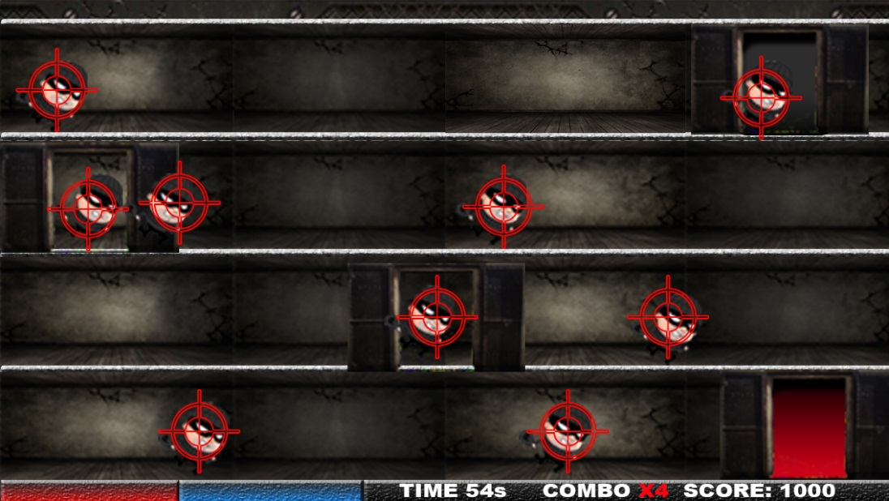

*Figure 3.5 Tap the Robber: Arcade Mode Crosshair Power up*

The duration of the power up is also shown in the button itself.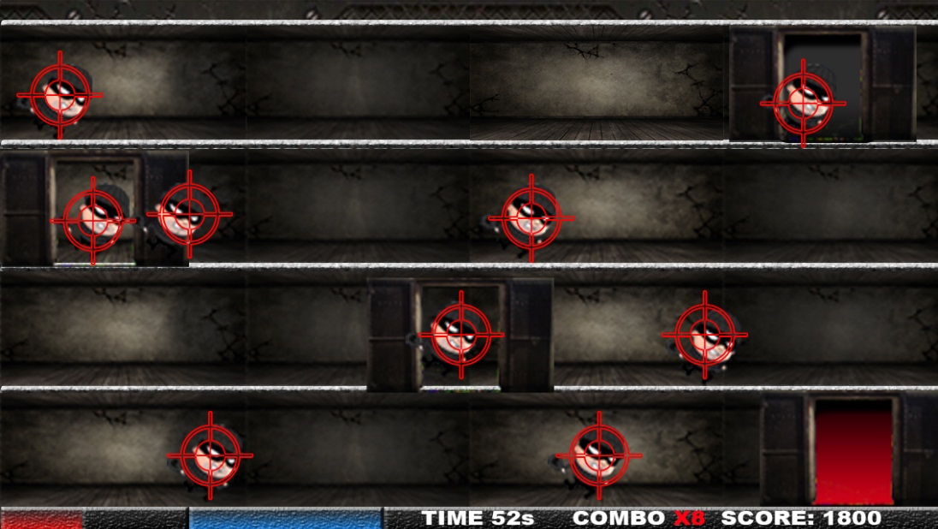

*Figure 3.5.1 Tap the Robber: Arcade Mode Crosshair Power up*

Once the power up is used up the button will show a black button which will tell the player that it’s not ready for use. The player can now fill up the gauge by tapping on robbers with the corresponding color outline.

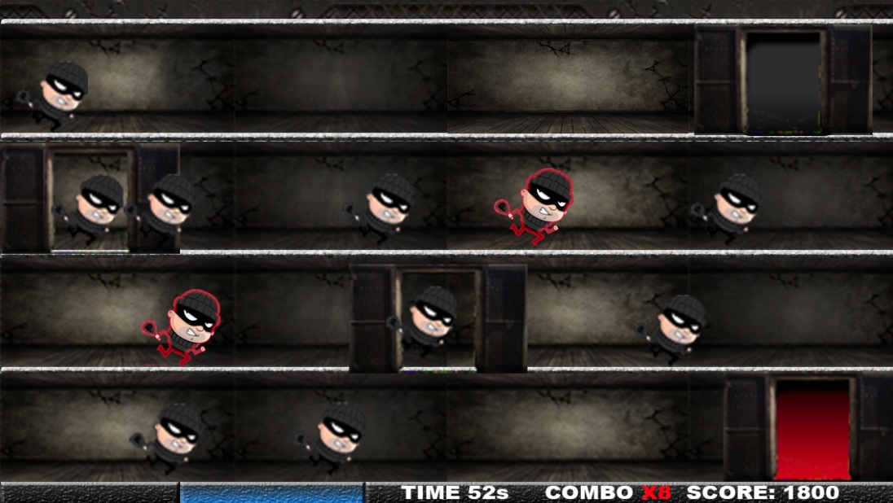

*Figure 3.5.2 Tap the Robber: Arcade Mode Crosshair Power up*

The next power up for the arcade mode is the freeze in which it freezes the robbers and the time. To fill up the gauge of this power up the player needs to tap the robbers with blue outline just like in the first power up.

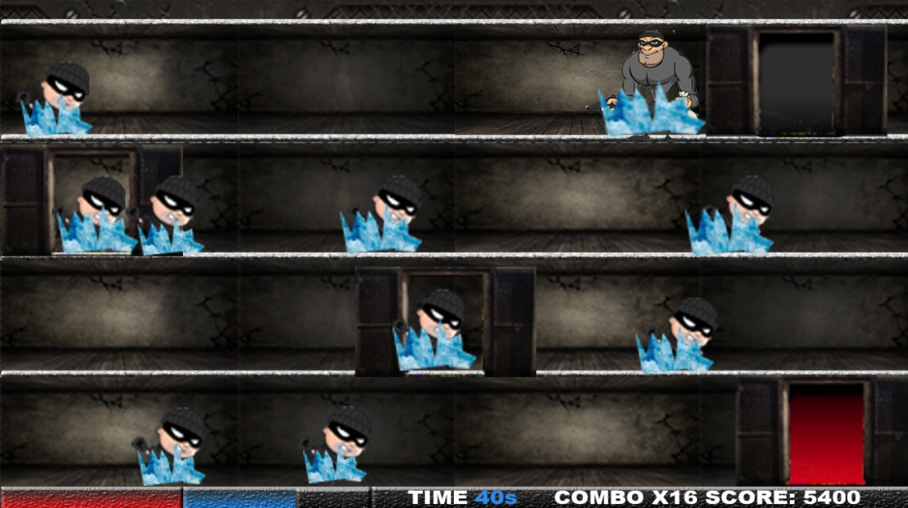

*Figure 3.6 Tap the Robber: Arcade Mode Freeze Power Up*

The scoring system for the arcade mode is based on the combo of the player (i.e. 1 small robber x 20 combo = 20 points) if the player fails to continuously tap on a robber the combo will then be rest back to 1. If the crosshair power up is activated the computation will be (i.e. 1 small robber x 2 power up effect x 20 combo = 40 points).

For every arcade mode played, gold is accumulated so that the player can buy upgrades from the upgrades interface. The gold conversion depends on the score (1000points = 5 gold).

The final game mode is the story mode. The story mode will first show a story on how the player finds out about the robbers of his country. While watching the slides the player has the option to skip the story and continue to the game.



*Figure 3.7 Tap the Robber: Story Mode*

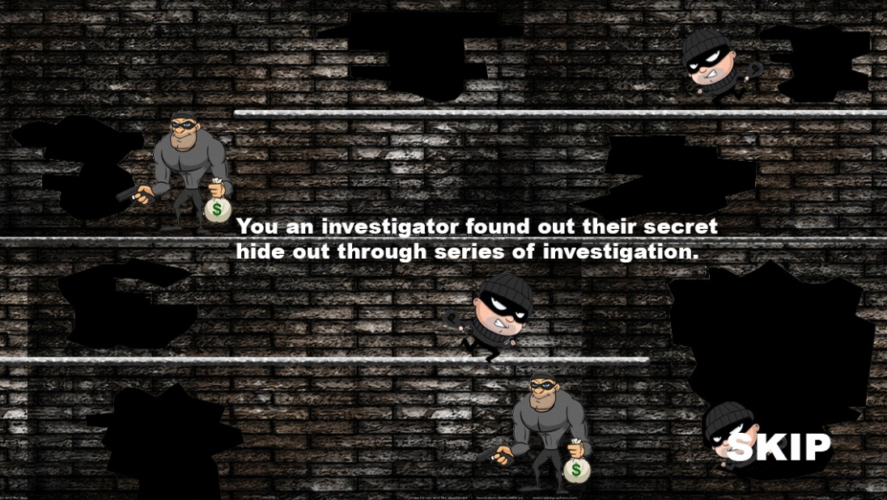

*Figure 3.7.1 Tap the Robber: Story Mode 2nd scene*

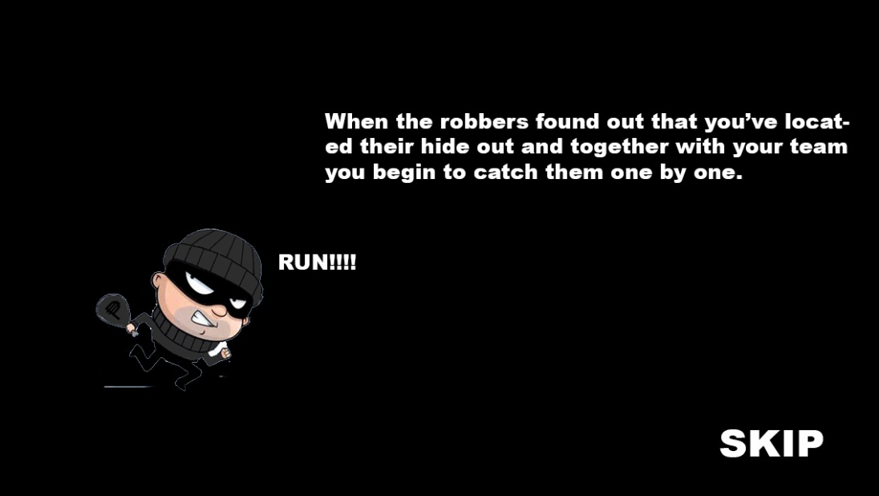

*Figure 3.7.2 Tap the Robber: Story Mode 3rd scene*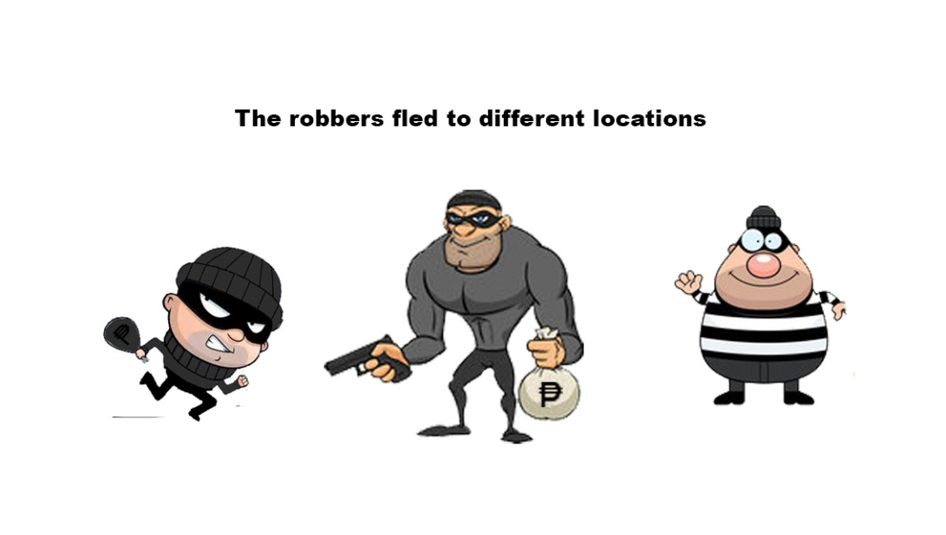

*Figure 3.7.3 Tap the Robber: Story Mode 4th scene*

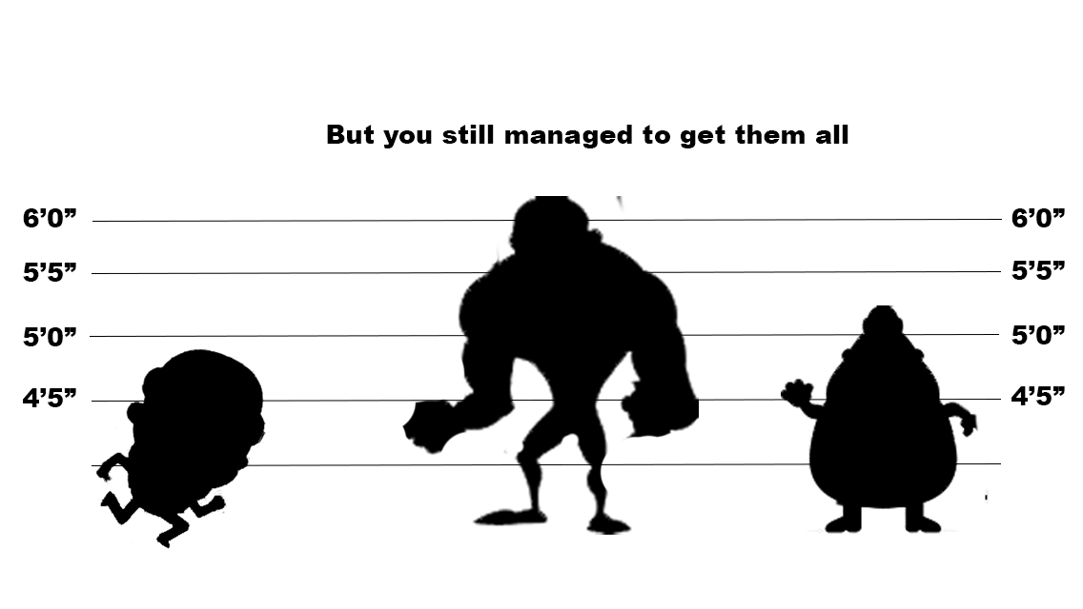

*Figure 3.7.4 Tap the Robber: Story Mode 5th scene*

The stages for the mode is a lot like the time attack mode but the difference is that in this mode the player has lives as he goes along the game for every robber that escapes to the end of the stage which is marked by a red color the player will lose a life.

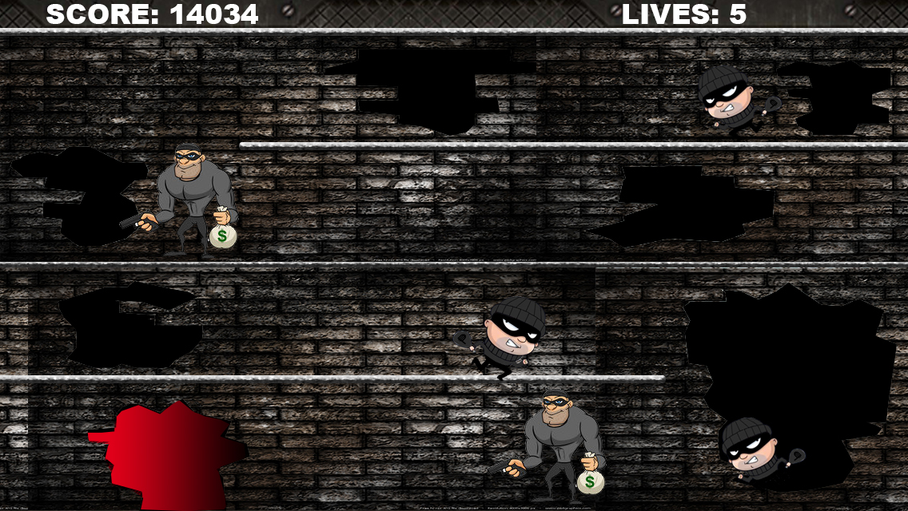

*Figure 3.8 Tap the Robber: Story Mode Actual Game*

Sometimes there will be civilians that will randomly pop up on each stage. If the player accidentally taps one of the civilians the player’s life will be deducted by 1.

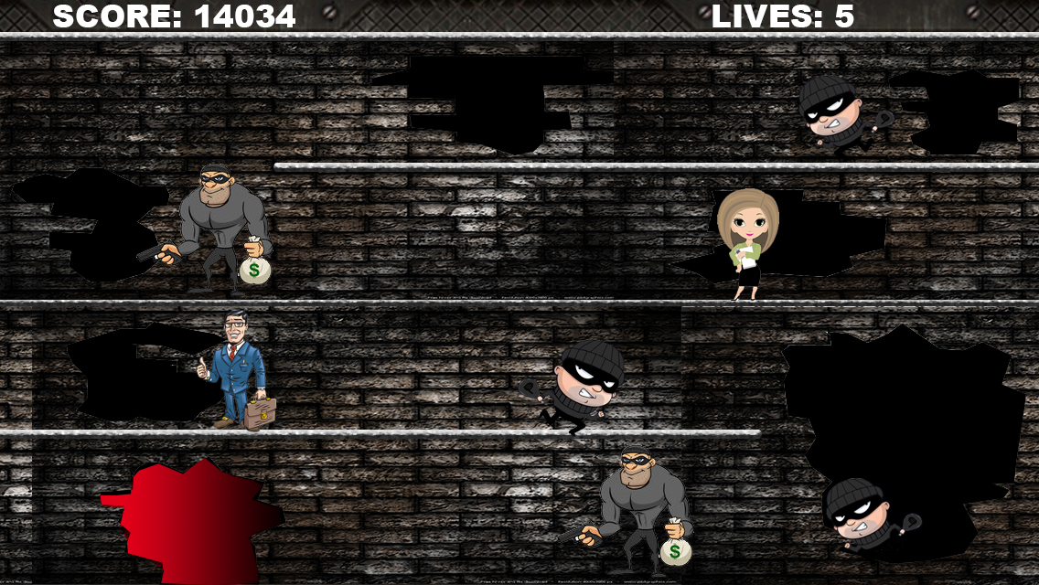

*Figure 3.8.1 Tap the Robber: Story Mode Actual Game with Civilians*

The next screen is where the player could shop for upgrades for arcade and additional lives for the story mode.

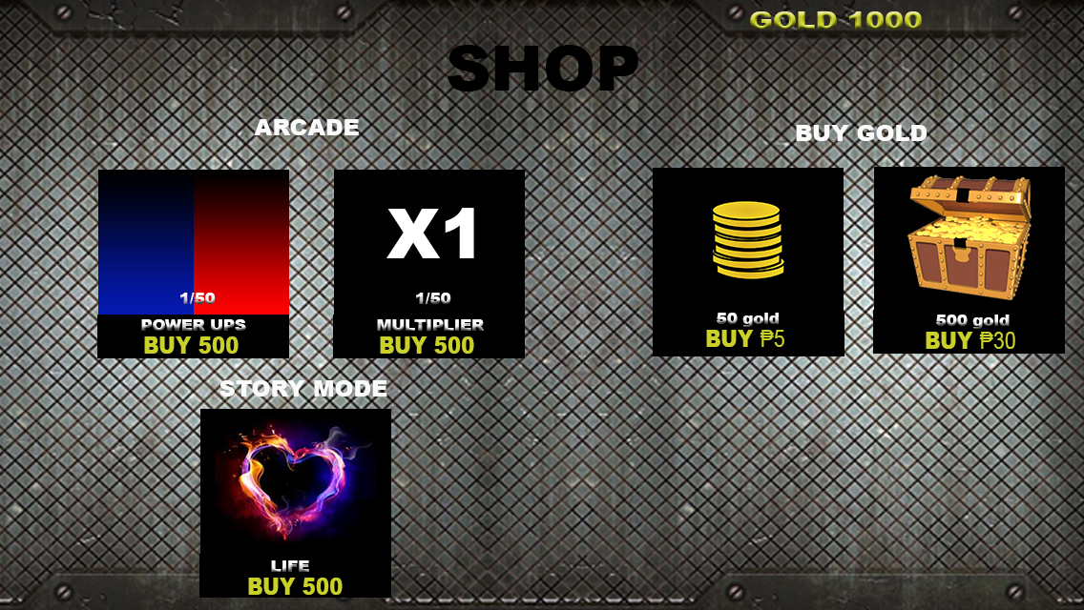

*Figure 3.9 Tap the Robber: Shop*